Jaco Sittig  
Head of IT Engineering

123 Milky Lane

Sandton

2146

14 April 14, 2018

Werner Pieters

Head of Network Engineering

CAI

123 Milky Lane

Sandton

2146

Dear Werner Pieters:

I am writing to you about a concerning problem about the network service in the company CAI. During the month of March, I have had multiple network failures and a devastating SAN crash that caused data to be lost.

CAI is a cyber security company that needs stable, secure networks for company use and for customers that use our services. If these problems continue and continue to grow, we as a company can have devastating losses, in terms of revenue and key integrity data about our products and client information.

When I contacted your department, I was very surprised in the lack of your worker’s abilities in fixing the problem and caring for this serious problem that I reported.

As networks are the backbone of all good IT companies, these problems need to be faced head on. I trust that you, Head of Network Engineering, will fix these problems and get your department back up to its former high standard.

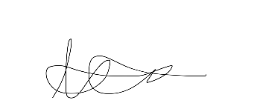Sincerely,

Jaco Sittig  
Head of IT Engineering

Well I don’t like your attitude very much kind sir, I think you should go and suck it

Well if you don’t like it when it is your problem, and you can keep it to yourself